**Assessment Report**

Full-Stack Software Engineer Assessment

SIEMENS

Table of Contents

Deliverable 1: 3

System Architecture: 3

3

Design Choices: 3

Deliverable 2: 4

Schema: 4

Backend overview and constraints: 4

SQL Queries 8

1. Get all documents accessible to a user in their department. 8

2. Get the 10 most recently uploaded documents tagged as Finance. 8

3. Find all versions of a given document (by document ID). 9

4. Get the number of documents uploaded by each department in the last 30 days. 9

Proof of Concept (POC) Project 10

Backend (API) Endpoints: 10

API Documentation: 10

Frontend: 11

Figma UI Design 11

Pages: 12

Deliverable 3: 18

GitHub Repo Link: 18

Video Link: 18

# Deliverable 1:

## System Architecture:

## 

## Design Choices:

* **React + TS + Tailwind** → modern, flexible, rapid prototyping ,clean UI and components based architecture.
* **JWT Auth** → stateless, secure, well-suited for SPAs.
* **FastAPI** → lightweight, async-first, automatic API docs.
* **SQLite** → minimal setup, good for development & testing (we can then migrate to **PostgreSQL** in production)
* **Local FS** → free, no extra dependencies (we can then migrate to cloud based storage for production **(e.g. Amazon S3)** to be more reliable and scalable)

# Deliverable 2:

## Schema:

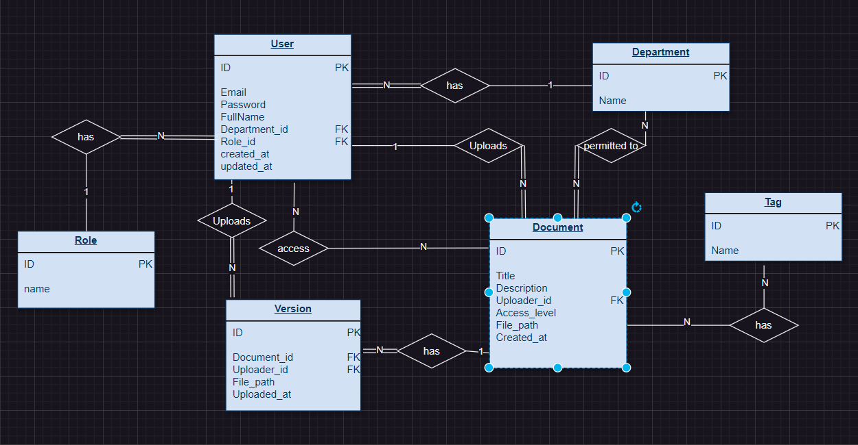

### Backend overview and constraints:

**Access Control Model**

The system enforces **multi-layered access control** to documents:

1. **User Roles (global) (admin & user)** (we can add super admin in the future)
2. **Department Membership**
3. **Document-Level Permissions**

Each layer refines who can view documents.

**1. User Roles**

* Users are assigned one role (users.role_id → roles table).
* **Default roles identified in the system**:
  + **Admin**: Full access to all documents and operations (create/update/delete users, departments, roles).
  + **User**: Can create and manage documents they own and documents accessible to their department or explicit permissions.
* **Role enforcement**:
  + Certain endpoints require get_current_admin_user to authorize admin-only operations.
  + Role-based restrictions are applied globally before checking document-specific permissions.

**2. Department Membership**

* Each user belongs to a department (users.department_id → departments).
* Documents can have an access_level:
  + **public**: Accessible to all authenticated users.
  + **department**: Only users in the same department as the uploader can access.
  + **private**: Restricted to the creator user or explicit users via document-level permissions.
* Departments can also be granted **document-level overrides** via the DocumentDepartmentPermission table.
* Example:
  + A document with access_level='department' uploaded by Finance is visible to Finance department users.
  + Legal department can be explicitly granted access via DocumentDepartmentPermission.

**3. Document-Level Permissions**

* **Explicit granted control** through two tables:
  1. **DocumentUserPermission**:
     + Maps user_id → document_id with permission.
     + Overrides general access rules for specific users.
  2. **DocumentDepartmentPermission**:
     + Maps department_id → document_id with permission.
     + Overrides general department-based access.
* Example:
  1. Document marked as private:
     + Only users in document_user_permissions or the uploader can access it.
  2. Document marked as department:
     + Users in the department can access by default.
     + Additional departments can be granted access through document_department_permissions.

**4. Access Decision Flow**

When a user requests a document (can_access_document helper):

1. **Check global role**:
   * If user.role.name == "admin" → grant full access.
2. **Check document access_level**:
   * public → allow.
   * department → check if user.department_id == document.uploader.department_id.
     + If not, check explicit document_department_permissions.
   * private → only uploader or explicit document_user_permissions can access.
3. **Explicit permissions overrides**:
   * Check DocumentUserPermission for user-specific access.
   * Check DocumentDepartmentPermission for department-specific access.
4. **Otherwise** → deny access.

**5. Document Versions**

* **Versioning implemented via DocumentVersion table**:
  + Each document can have multiple versions.
  + Versions are tied to the uploader (uploaded_by) and maintain version_number.
  + Download and inline preview respect the same access control rules (can_access_document is reused).

**6. Tags**

* Documents can be tagged (Tag and DocumentTagLink tables).
* Tag-based search is integrated with access control (only returns documents the user can access).

**8. File Storage & Access**

* Uploaded documents stored in Documents/ folder with unique UUID filenames.
* Versions have separate files with version UUID.
* Downloads use FileResponse and respect access control.
* Inline viewing is supported via /documents/{doc_id}/file or /versions/{version_id}/file.

**9. Security Notes**

* Authentication via JWT (OAuth2PasswordBearer).
* Passwords hashed using hash_password utility.
* Token expiration handled via settings.ACCESS_TOKEN_EXPIRE_MINUTES.
* Admin-only operations explicitly enforced via get_current_admin_user.
* All file access checks through can_access_document to prevent unauthorized downloads.

## SQL Queries

### 1. Get all documents accessible to a user in their department.

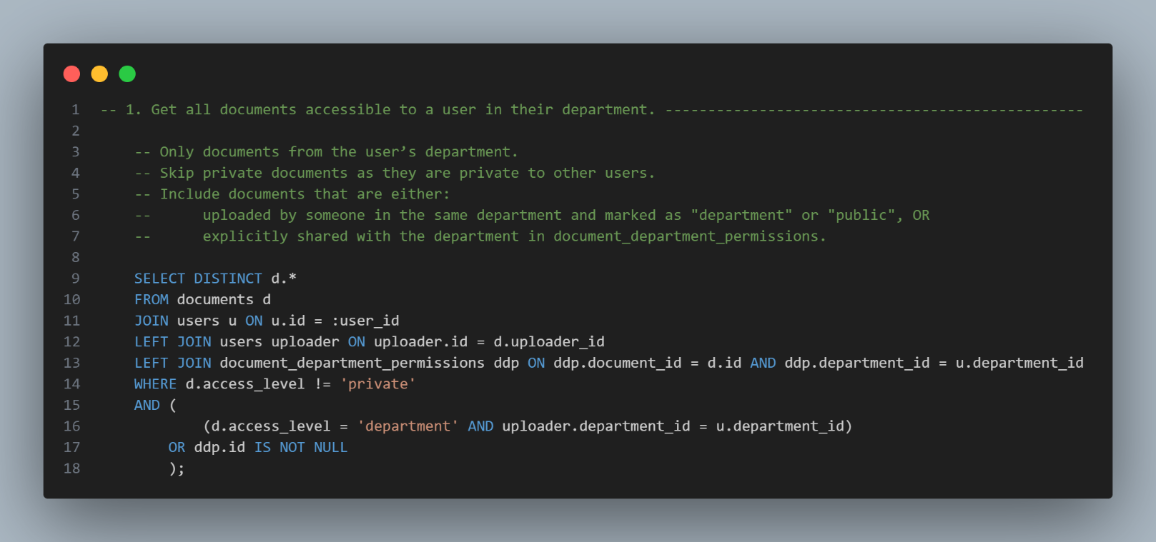

### 2. Get the 10 most recently uploaded documents tagged as Finance.

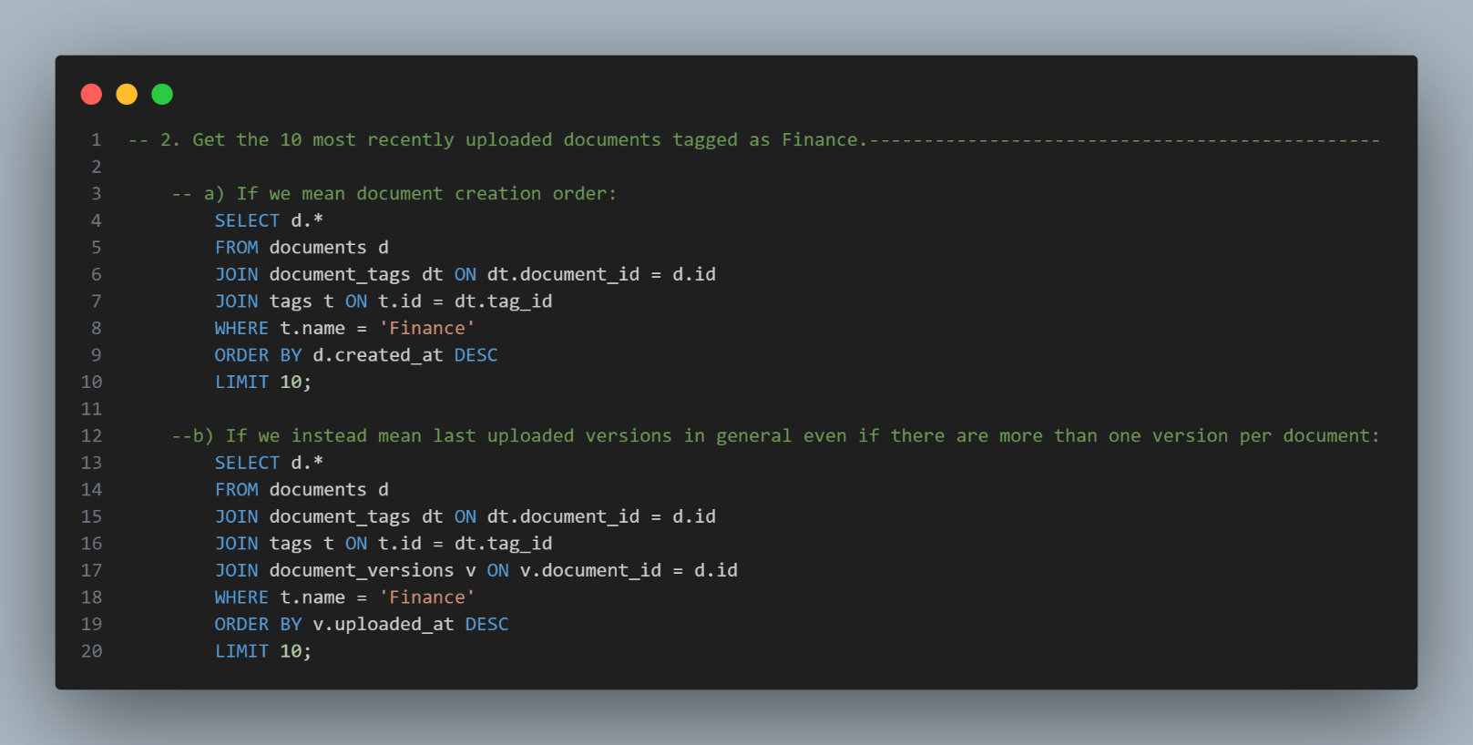

### 3. Find all versions of a given document (by document ID).

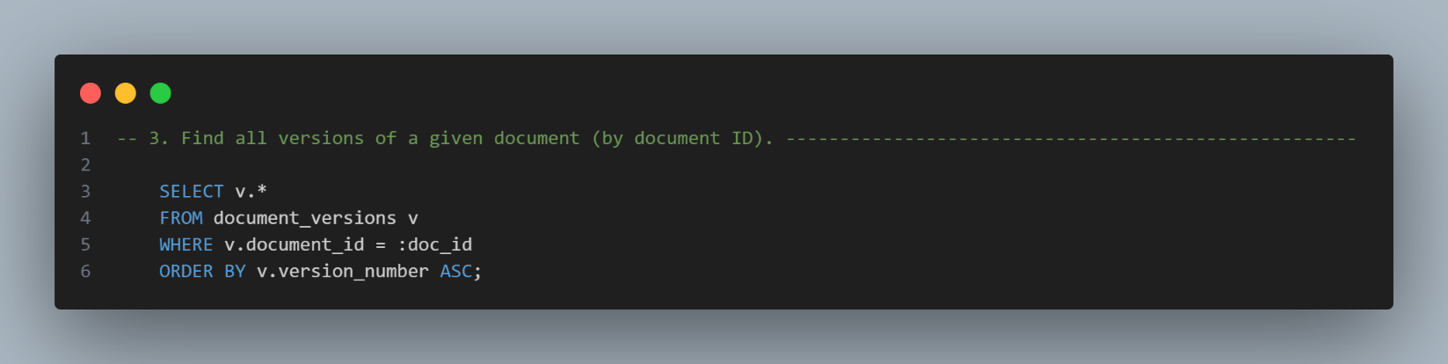

### 4. Get the number of documents uploaded by each department in the last 30 days.

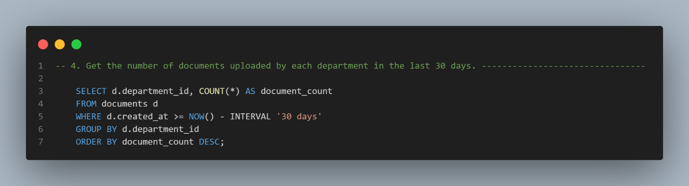

# Proof of Concept (POC) Project

## Backend (API) Endpoints:

All the required endpoints [User registration & login, Upload document (store file + metadata), Search documents (by title, tags, uploader), View/download document, Fetch version history of a document.] are implemented and more endpoints.

All the required endpoints are integrated with the frontend and shown in the video.

### API Documentation:



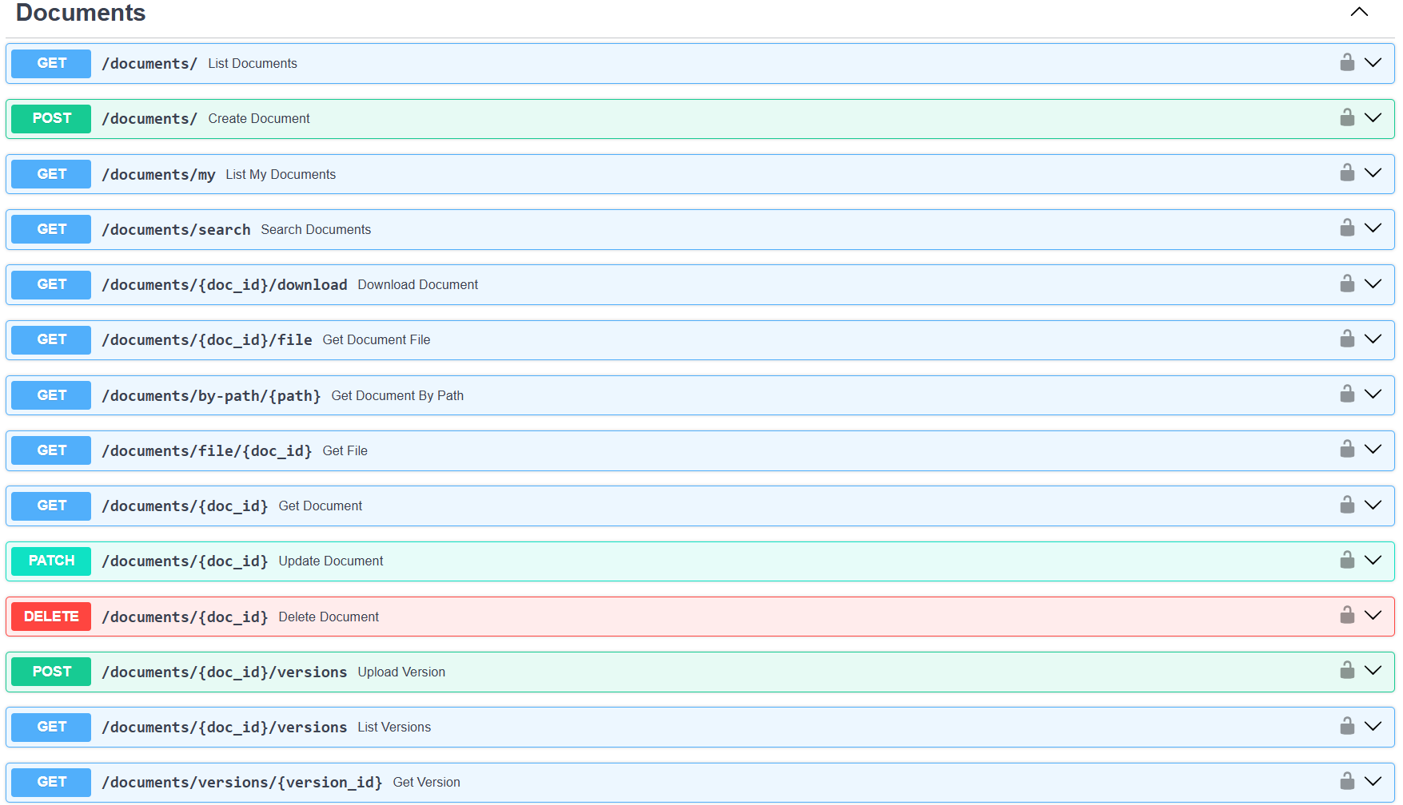

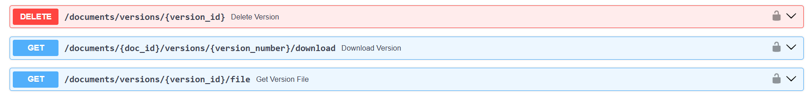

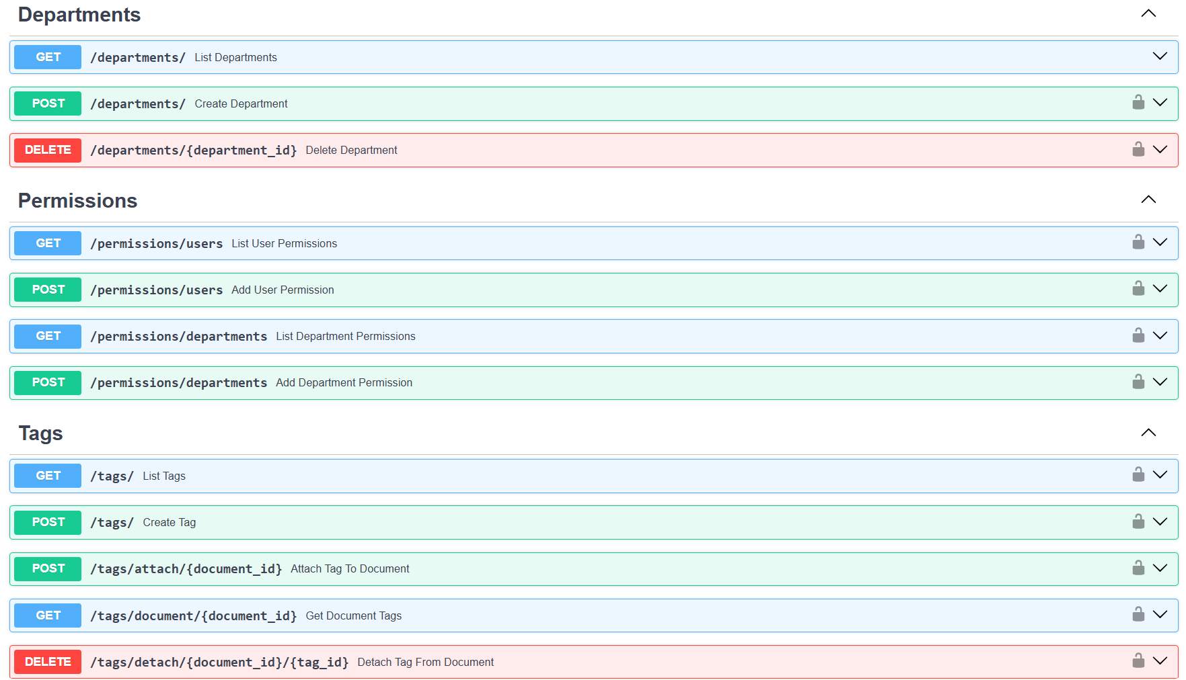

## Frontend:

### Figma UI Design

Started with Figma design for pages layout and choosing the color palette for themes.

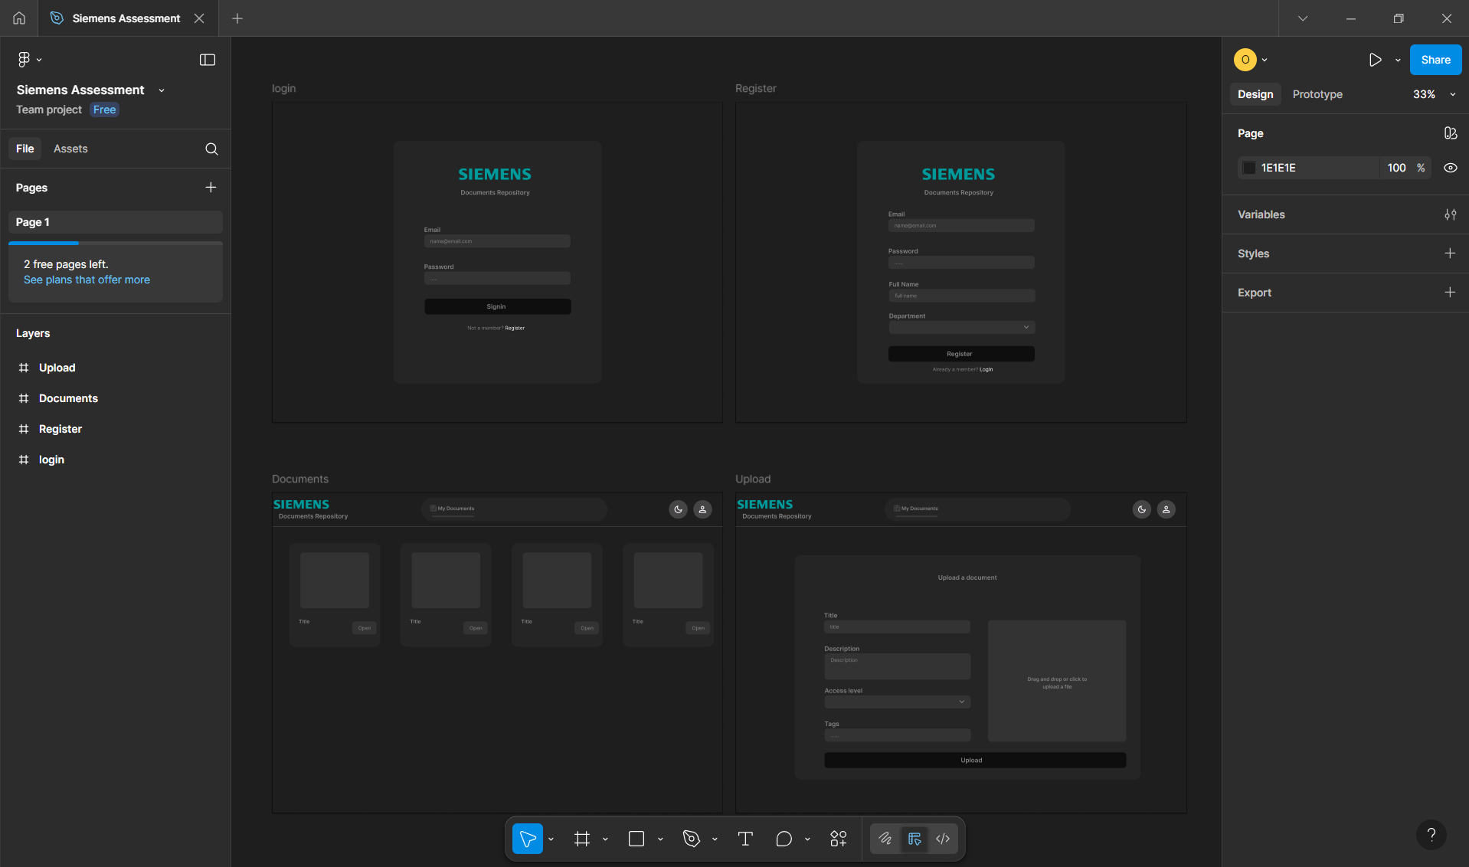

**Note:**  
All the frontend components and pages are fully responsive to handle different screen sizes and have dark and light themes handled

### Pages:

**1. Login Page**

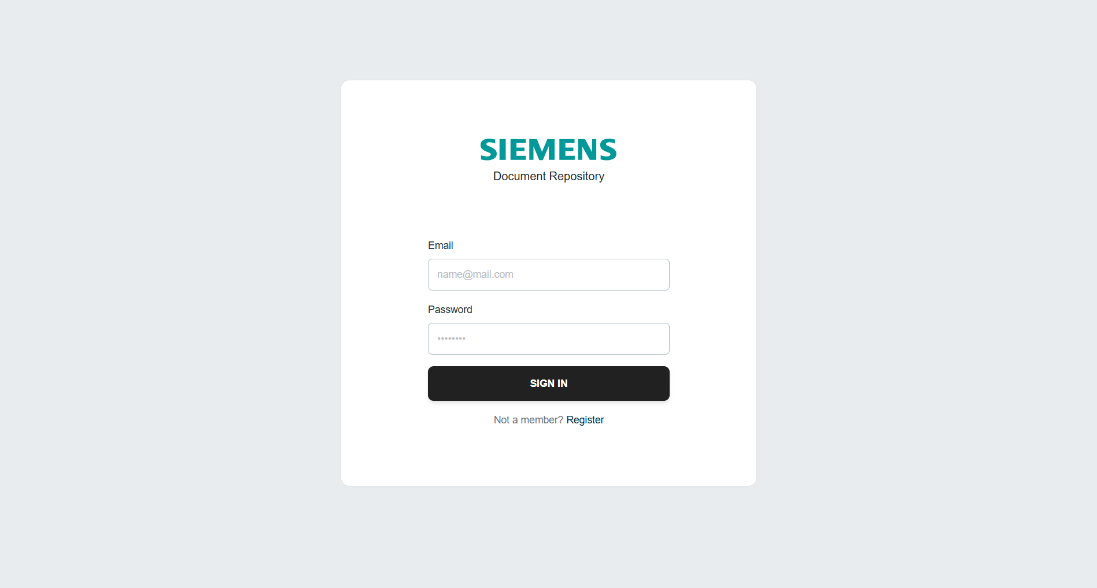

* Form with email + password.
* On submit: sends credentials → gets token → saves to localStorage.
* Handles loading + error (“invalid email/password”).
* Link to register page.

**2. Register Page**

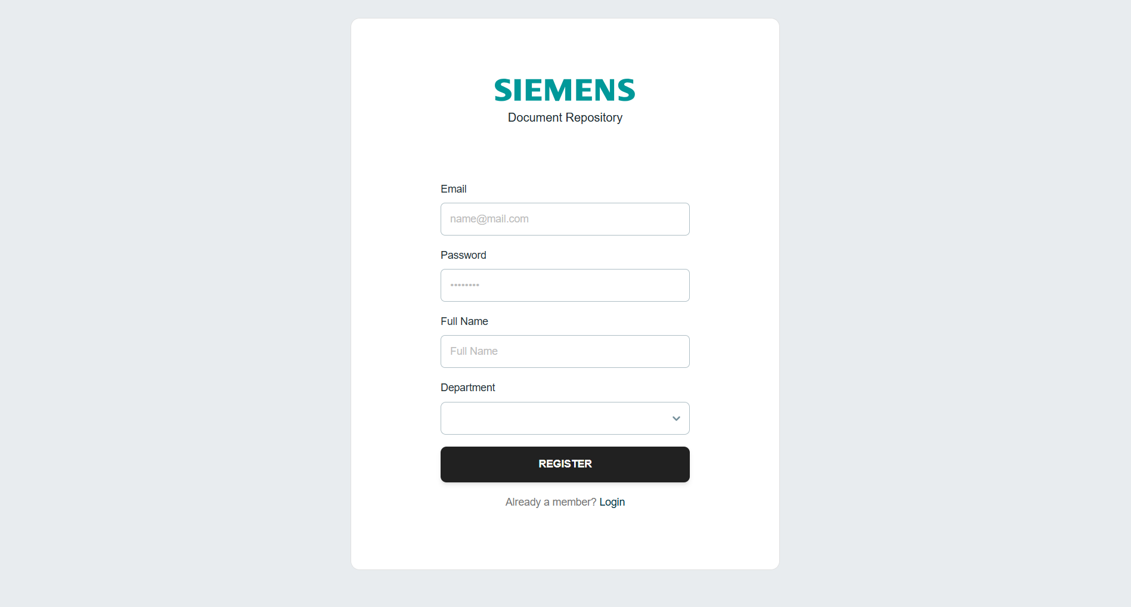

* Form with email, password, full name, and department selector.
* Fetches department list from backend.
* On submit: creates user → stores token → redirects to home.
* Handles loading + errors.
* Link to login page.

**3. Documents Page**

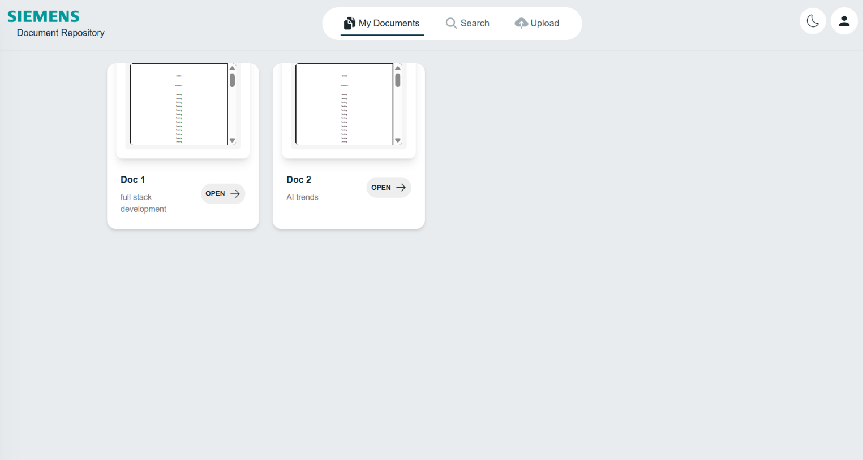

* Lists user’s documents in a grid.
* Each card: preview (image/pdf/placeholder), title, description, and “Open” button.
* Handles loading, empty state, and failed previews.

**4. Document Detail Page:**

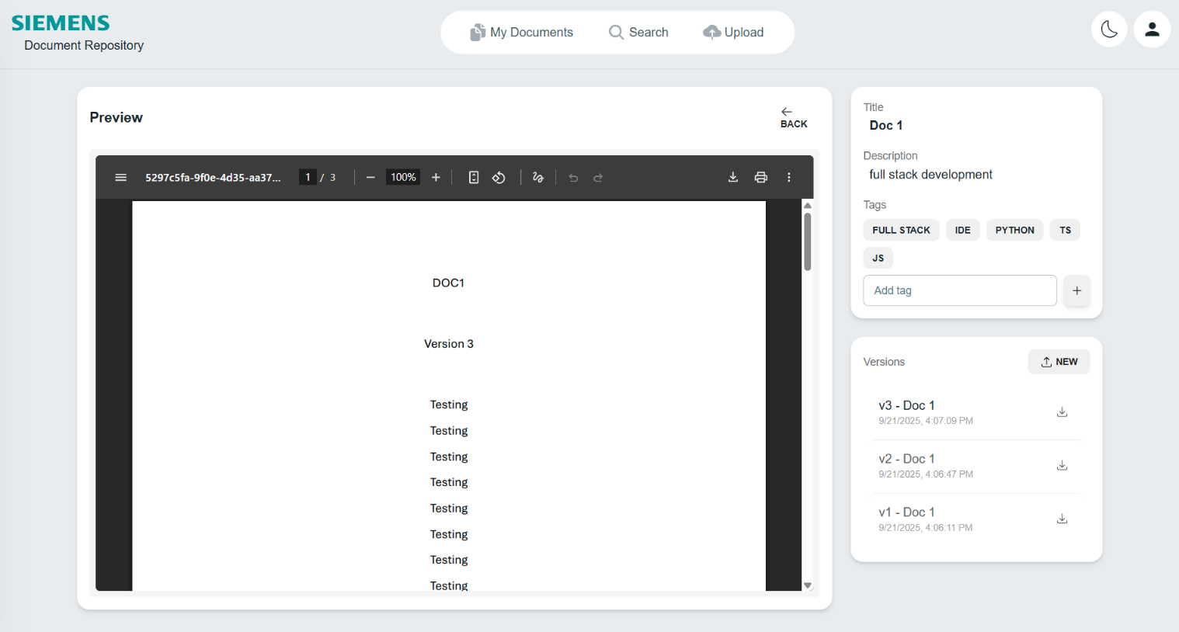

* Shows one document with metadata, tags, and versions.
* Features:
  + Preview latest version (PDF/image/none).
  + Switch between versions.
  + Download versions and upload new versions.
  + Add new tags.
  + Upload new version (modal).

**5. Upload Document Page:**



* Form with title, description, access level, tags, and file upload.
* Drag & drop or browse file.
* On submit: uploads doc + attaches tags.
* Redirects to detail page after success.

**6. Search Page:**

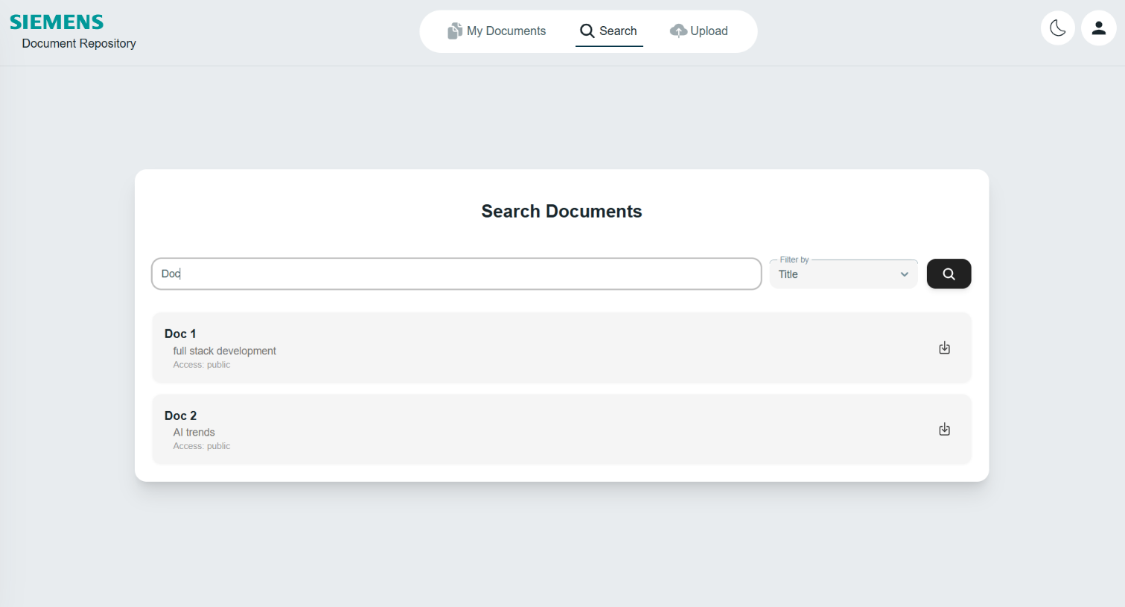

* Search bar + filter (title/tags/uploader).
* Paginated results.
* Each result: title, description, access level, open button, quick download latest version.
* Shows loading, empty, and results states.

# Deliverable 3:

## GitHub Repo Link:

<https://github.com/OsamaElHattab/Document-Repository>

## Video Link:

<https://drive.google.com/drive/folders/1rhynOEa1RElwSJ5TEJ_YL5ogLGW7vQ80?usp=sharing>